**Title:** Lab 10. MOSFET Amplifier

**Name:** Robert Bara

**General Objective:** This lab is designed to design and simulate a MOSFET common source amplifier to calculate gain through DC and AC analysis.

**Background Activities:**

The common source MOSFET amplifier grounds the source terminal, thus cancelling the nonlinear relationship between VGS versus ID. The common source MOSFET amplifier appears as follows:

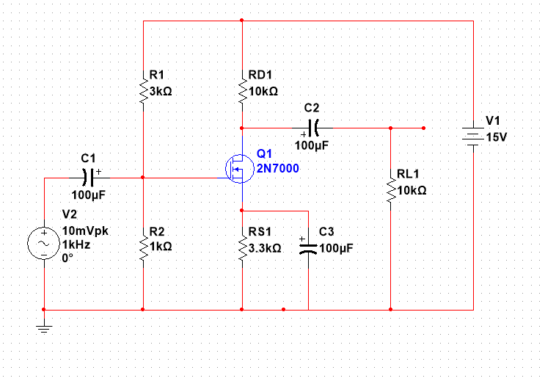

Figure . Common Source Amplifier

Based on the wiring/bias configurations, the following voltage divider can be used to find VGS:

VGS=VDD*(R2/R1+R2), where VGS=VG-ID*RS

Transconductance of a transistor is the deviation of drain current regarding the gate voltage. Transconductance can be found as follows:

gm=∆iD/∆VGS=2*ID/VGS-Vt

The gain factor Av is then calculated when r0>>RD||RL

Av=-gm*(RD||RL||r0) ≈-gm(RD||RL)

**Procedure**

**Part 1**

A DC analysis can be ran for the following common source MOSFET amplifier with values R1=3k, R2=1k, RD=10k, RS=3.3k, RL=10k, and C1=C2=C3=100uF. A suggested MOSFET could be a 2N7000 where Vt=25mV. The circuit should appear as follows:



Figure 2. The Common Source Amplifier

Removing the AC source for DC analysis. The following DC values for VG, VS, VD, ID, VGS, and VDS should be measured from a DC interactive simulation, in order to calculate the transconductance and voltage gain.

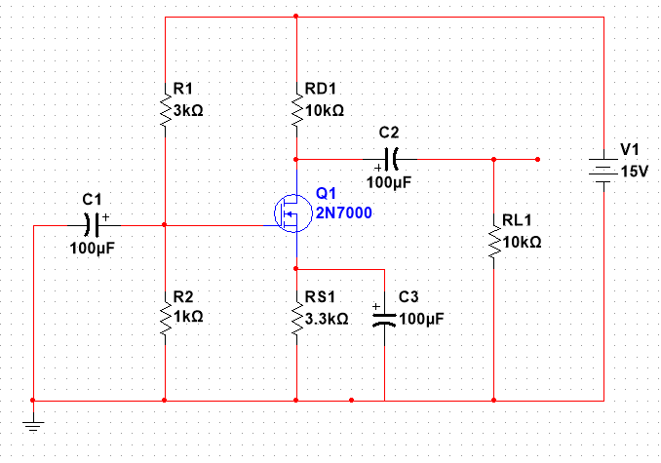

Figure 3. DC Analysis of the Common Source Amplifier

**Part 2**

By adding the AC source back in to apply a 10mV peak, 1kHz sinewave Vin signal (refer to figure 2), determine the voltage gain, that is to say Av=Vout/Vin.

**Results:**

* 1. **Simulation Results**

**Part 1**

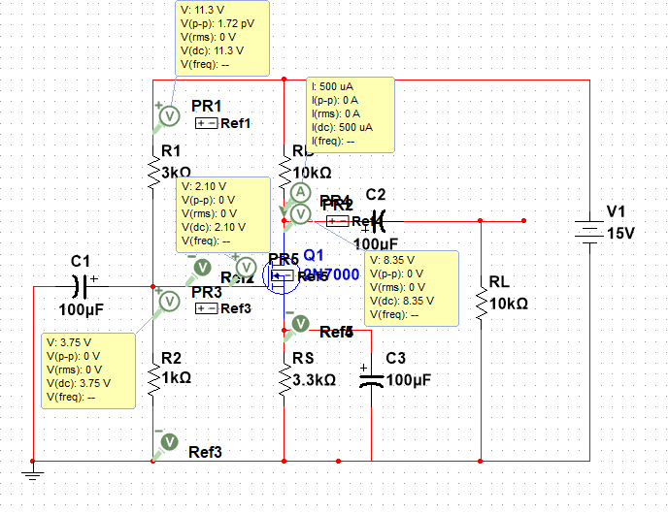

Figure 4. Measuring V1&V2 to find VG, VGS, VDS, and ID

From the values, I was able to calculate the DC values of VG, VS, VD, VGS, VDS, IS with the use of excel. From these values I calculated the gm and gain factor using the proper equation:

|  |  |  |  |
| --- | --- | --- | --- |
|  | Values | Voltage [V] |  |
| R1 | 3.00E+03 | 1.12E+04 |  |
| R2 | 1.00E+03 | 3.75 |  |
| RD | 1.00E+04 |  |  |
| RS | 3.30E+03 |  |  |
| RL | 1.00E+04 |  |  |
| C1 | 1.00E-04 |  |  |
| C2 | 1.00E-04 |  |  |
| C3 | 1.00E-04 |  |  |
| Vt | 2.50E-02 |  |  |
| VDD | 1.50E+01 |  |  |
|  |  |  |  |
|  | Measured Part 1 |  |  |
| VG | 5.02E-03 | VG=Vdd*(R2/R1+R2) | [V] |
| VS | 1.65E+00 | VS=VG-VGS |  |
| VD | 1.00E+01 | VD=VDS+VS |  |
| ID | 5.00E-04 | [A] |  |
| VGS | -1.64E+00 |  | [V] |
| VDS | 8.35 |  |  |
| gm | -5.99E-04 | gm=2ID/(VGS-Vt) |  |
| Av | 1.49E+00 | Av=-gm(RD||RL) |  |

**Part 2**

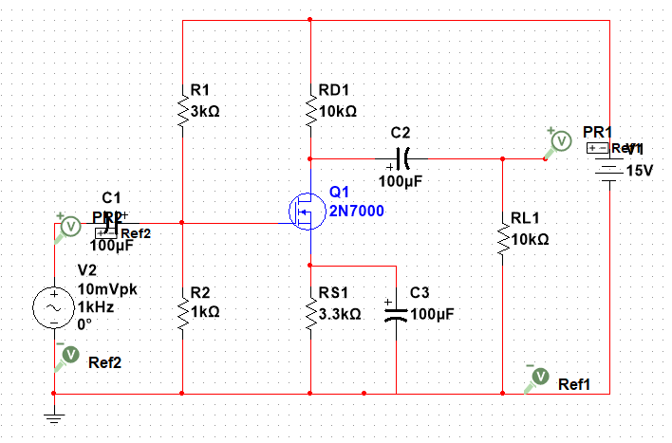

Figure 5. Adding the AC Signal and probes for Analysis

Running a single AC sweep, I set the frequency for each line to sit at when X=1kHz, which yielded a magnitude of 29.1960 for Vout compared to 1 for Vin, therefore to find gain Av=Vout/Vin=29/1=29. Meaning there is a gain factor of 29.

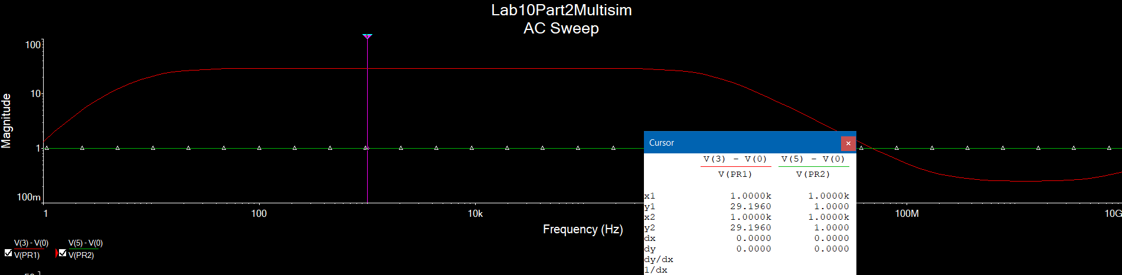

Figure . AC Sweep to find Gain.

A gain control can be implemented without changing the biasing point by manipulating RS which is determining how much signal should be fed to the ground. From ohms law, V=IR, therefore R=V/I, where as R increases, voltage decreases. By increasing RS there will be more signal going to ground, while decreasing RS will allow more signal to be amplified out of the Drain. For flexibility, a potentiometer could be wired so terminal 1 comes out of the Source and terminals 2 and 3 are wired to ground. I can prove this by changing RS from 3.3k to 10k, generating the transient response below where Vo is now almost half the gain it was during Part II’s analysis:

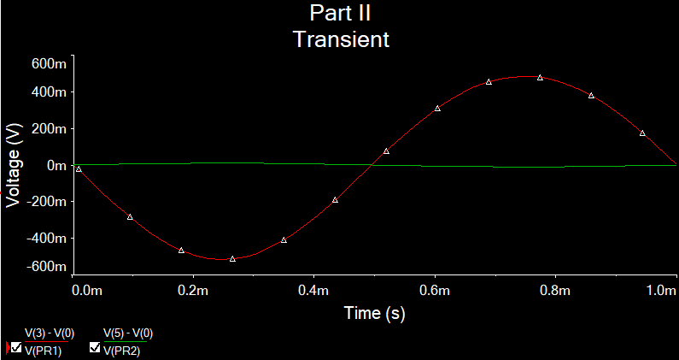

Figure 7. Transient Response to find Av

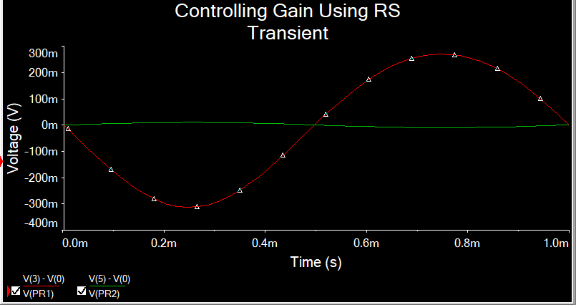

Figure 8. RS=10k, Gain Decreases

1. **Conclusion:**

This lab simulated common source amplifiers which could be useful for not only the class AB audio power amplifier SPICE project, but general amplifier design within electrical engineering. The lab practiced DC and AC analysis of the amplifier and also posed the question to determine how one could manipulate the gain factor of a transistor amplifier without changing the bias point, this way the amplifier may work with smaller or larger input signals.